LIMS

Functional

System

Design

05AU0092
J. Wesselink
H. van Benthem
M. Groote Schaarsberg
28 September 2005

0. Introduction

In order to stay profitable as a company, product development is very important. Vredestein did speed up this process during the last years in order to be able to introduce two new products every year. Under normal conditions it takes about 3 years to develop a new tyre, so many developments are carried out in parallel.

In the current situation several separate IT-systems are operational for registration of product specifications and test results. An integral overview is not possible, because all these systems are not integrated.

In order to make the development process more efficient, the management decided to introduce a new integral IT-system for the R&D department. This system must replace all existing systems supporting:
- Development and registration of product specifications (including tolerances)
- Interfacing these product specification to the manufacturing spec in our manufacturing systems.
- Workflow management regarding requests for manufacturing of sample material, taking samples, performing sample preparation and tests.
- Supporting the processes with templates for routine activities
- Registration of all test data
- Analysis of tests and relations between tests.

This Functional System Design (FSD) is a description of the desired functionality: The main document describes the processes, the current situation and the new situation
In the appendices detaill information is stored. This information is not complete and the appendix will be used to store more detail information when it is available.

Content

1. Content 3
2. General overview 4
2.1. Vredestein organisation 4
2.2. Current software landscape 7
2.3. New situation general overview 13
3. Product specifications 14
3.1. Introduction 14
3.2. General 16
3.3. Raw materials 20
3.4. Compounds 20
3.5. Reinforcement material 20
3.6. Semi-finished products 21
3.7. (green-) Tyre 21
3.8. Possible datamodel 22
4. Requests 24
4.1. General 24
4.2. Production tool creation request 25
4.3. Article manufacturing request 26
4.4. Testing request 27
5. Article manufacturing and testing 31
5.1. Introduction 31
5.2. Article manufacturing 31
5.3. Testing 31
5.4. Laboratory supporting processes 34
5.5. Possible datamodel: 36
6. Analysis and reporting 39
6.1. Introduction 39
6.2. General analysis and reporting facilities 39

General overview

Vredestein organisation
Vredestein tyres B.V. is a part of the Amtel group. The company develops, produces and sells tyres for cars, bicycles, agricultural equipment and other industrial purposes.
Vredestein headquarters is located in Enschede. The main production location for car tyres and agricultural tyres is in Enschede where also the R&D is located. Other production facilities are located in Asia and Russia.

For more general information visit www.vredestein.com .

TCE (Technical Centre Enschede)
The R&D centre “Technical Centre Enschede” has a total of 72 employees, mainly mechanical, automotive and chemical engineers with a Masters or Bachelor degrees.
The main activities are threefold:
- Development of Passenger car tyres (Winter, Summer and All Season), Light Truck tyres, Sports Utility Vehicle tyres (Summer and winter), Folded Spare tyres and Agriculture tyres for the Vredestein tyre group. This includes also the development of the tyre components, reinforcing materials, rubber compounds and full in- and outdoor testing of tyres and components.
- Development and suport of the production processes.
- Basic Research of all relevant technological areas of interest for the Vredestein group. Like: silica compounding, tyre modeling, advanced production methods, run on flat technology, sensors, tyre-road noise, fatigue, wear characteristics
- Quality & Enviromental Assurance. Including ISO certifications and product specification control.

The facility has it’s own indoor test facilities for Endurance and High speed testing, High Speed Infrared analyses, Laser Tread Wear scan, dynamic footprint analyses, and dynamic tyre tests. A special equipped outdoor test group has over 20 different modern vehicles for car testing at all required speeds at several test tracks in Germany, Italy, France, Finland, Italy, New Zealand and The Netherlands.
For Material research and competition benchmarking, it has a fully equipped (state of the art) Physical and Chemical laboratory .
For the Tyre design and modeling TCE uses the latest 3-dimensional CAE system CATIA and FEM software ABAQUS, both of Dassault.
Partners in research include Universities in Germany and The Netherlands and research institutes in Germany, The Netherlands and the US.

TCE organization
The TCE organization structure contains the following departments.
- Construction and design:
This department is responsible for the design and construction of the tyre. For reference see appendix.
- Materials and technology:
This department is responsible for the compounds and cord materials in the tyre and the development of the related production processes. It contains also the materials laboratory
- Tyre testing
Laboratories for indoor and outdoor testing of tyres.
- Quality and environmental assurance

Roles
Within the departments the following roles can be distinguished:
- The specialist
- Creates and maintains article definitions
- Requests articles (materials/tyres) and tests
- Analyses and reports test results
- Project leader
- Manages projects on specific topics
- Test operator
- Performs the actual testing or manufacturing of articles (materials/tyres)
- Manager
- Approves article definitions before released in production
- Decides on priorities

Testing instances
Most testing is performed in a Vredestein testing instance. The following Vredestein testing instances can be distinguished:

Testing instance | Description
Preparation laboratory (part of the materials laboratory) | The preparation laboratory produces the green compound out of the ingredients and prepares sample material from production or from the laboratory.
Chemical laboratory (part of the materials laboratory) | Chemical analysis on:  - Raw materials.  - Green and vulcanized compounds.  - Samples cut out of tyres/products, or out of other articles in the production plant
Physical laboratory (part of the materials laboratory) | Physical analysis on:  - raw materials.  - Green and vulcanized compounds.  - Samples cut out of tyres, or out of other articles in the production plant
Tyre testing laboratory (group HdL – durability testing) | Indoor and Outdoor testing of tyres. Accent testing tyre durability.
Tyre testing laboratory (group JdG – tyre characteristics) | Indoor and Outdoor testing of tyres. Accent defining tyre characteristics.
Field Engineering PWB/LBB | Tyres are mounted on vehicles of customers and examined during and at the end of lifetime. The test is taking place at service conditions.
Product auditors | Quality audits performed by the QEA department.
Production | In the production plant some testing is performed:  - Standard production control. (rheometers, UF, collmann of tyres, dimensions and weight)  - Processing information (judgment and machine settings)

Scope of the LIMS system
The LIMS system should support the processes of specifying, requesting, testing, manufacturing of test articles and reporting.

The scope of the LIMS system is visible in the following data model

Processes are circles and data stores are squares
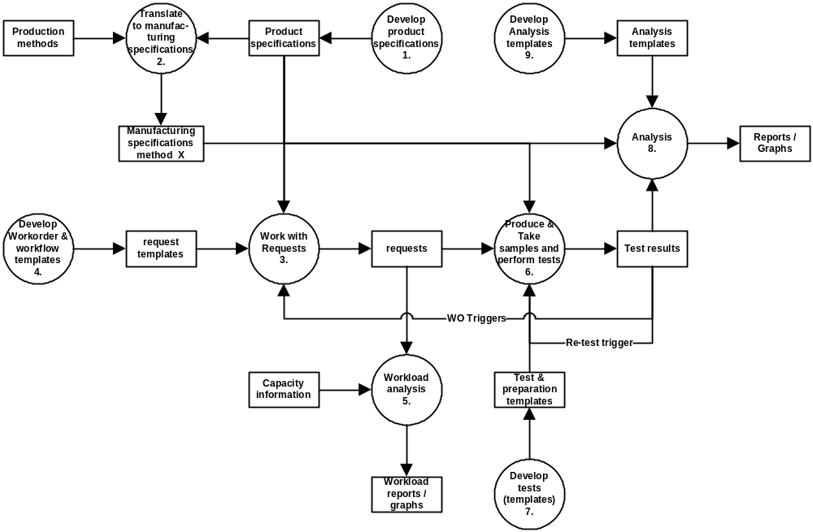

No | Process | Description / definition
1 | Develop product specifications | This must be the tool for our product developers for fast development of product variants independent of the chosen manufacturing method
2 | Translate to manufacturing specifications | This process will translate the product specifications into a manufacturing specification per available manufacturing method (APBM, HAPBM, YAZD, Amtel etc.)
3 | Work with requests | During the product specification phase a lot of sample taking, preparation, testing and analysis have to be carried out (compare different product variants). All this work will be coordinated via requests.
4 | Develop work order & workflow templates | Per article type, test method, department etc. several work order templates can be made
5 | Workload analysis & scheduling | This will support the workload analysis, prioritization and scheduling of requests against capacity limits
6 | Produce and take samples and perform tests | Requests can initiate: Manufacturing of sample material, Sample taking, Sample preparation, Sample testing and Sample stocking/scrapping.
7 | Develop tests (templates) | These activities are based on standard activity templates which can be developed
8 | Analysis | Analysis of test results
9 | Develop Analysis templates | Standard templates for analysis can be developed via standard reports or graphs

An example process
In the development process of a tyre, the product is optimized in several steps. In such a step building trial tyres is an important source of information. To get as much information as possible from a trial, the technique of design of experiments (DOE) is used. What this basically means is that you try to vary per variant only one parameter compared to a reference to look at the influence. This parameter can however be on every level (from evaluating new raw materials, other materials (compound recipes) to dimensions of semi-finished products and processing parameters or tools. When the data is analyzed, a clear overview of the parameters varied in combination with the test results is needed.

In the research besides the influence of certain parameters, also the correlation between the test results on different article types is essential. These data has to be delivered by the LIMS

In the next chapters these process are specified in more detail:

chapter 3: Product specification (Process 1 and 2)
chapter 4: Requests (Process 3, 4 and 5)
chapter 5: Article manufacturing and Testing (Process 6 and 7)
chapter 6: Analysis and Reporting (Process 8 and 9)
First an overview will be given from the current software situation.

Current software landscape
In the current situation Vredestein has several system’s and documents to store the necessary data. In this paragraph the (main) systems will be presented shortly.
Systems, files and reports are presented that:
- Are the single source of recipe/specification or test results
- Have functionality/data that has to reside in the LIMS
- Will be fed from the LIMS
The systems will be presented in groups depending on the area the solution is active. The systems covering more than one area are presented in the Generic systems section. After introduction of the system the relations and the new situation are laid out.

Generic systems

COMPOUND and DAISY

Function
- Registry of general raw material data
- Registry of compound recipes and specification
- Registry of static test data
- Registry of requests for lab research on material samples
- Registry of competitor analysis material test results
- Registry of test results of compound samples for the Production department (quality approval) and for experimental research.
- Automatic control of measuring & analytical devices
- Contains calculations and functionality that is specific for the rubber industry like ageing and preparation on samples and creating recipes in phr’s (parts per hundred rubber).
- Analysis of test results
  - queries
  - providing comparison graphs (x-y plots) of test results for different samples
  - export possibilities to MS-Excel.

Technical info
COMPOUND and DAISY is standard software working on Windows-NT-server. Supplier is Alpha/Eclipse. COMPOUND and DAISY are two applications working closely together. DAISY is used for the testing part and instrument coupling. Compound is used for specifications, requesting and reporting. We do have a software maintenance contract with them. In the rest of the document these two applications are referred to as COMPOUND.

New situation:
The system has disappeared. All data and used functionality is available in the LIMS

FITES passenger car tyre and FITES agricultural tyres

Function
- Registry of request for tyre tests by Tyre Engineers and QEA
- Registry of test results regarding tyre tests (Production approval and new developments)
- Registry of static test data
- Lookup for test conditions for a test, depending on the tyre
- Analysis of test results.
  - Straight report
  - Query possibilities. Tyre recipe data from SPECTRAC DB is used to related the test results to the tyre recipe.

Technical Info
FITES is a Vredestein development running on MS-Windows platform. Development tool Delphi is used. There is a link between FITES and SPECTRAC DB. The same program runs on two databases: one for passenger car tyre (FITES) and one for agricultural (FITES LBB).

New situation:
The system has disappeared. All data and functionality is available in the LIMS

SPECTRAC XLS

Function
- Advanced maintenance of (green-) tyre recipes and calculation of building method specific parameters
- Printing of the official tyre recipe and tyre dimension specification
- This is an incomplete specification as the control plan and performance specifications are not stored.
- Plotting of extrudates
- Create request forms for trial tyres (includes trial semi-finished products). These request are stored as separate XLS-sheets in which (later on) processing information and production testing is stored. When the request is posted, an e-mail is automatically send.

Technical info
SPECTRAC XLS is a single XLS-application that is created and maintained by the Vredestein R&D department and running on MS-Windows platform.

New situation:
The advanced maintenance may stay, but need to be closely linked to the LIMS. The requesting and reporting has to be moved to the LIMS.

Specifications

SPECTRAC DB

Function
- Registry of Passenger Car Semi-finished product specifications and recipes
- Registry of Passenger car tyres product specifications and recipes
- Querying on these data.

Technical info
SPECTRAC DB is a Vredestein development running on MS-Windows platform. Development tool Delphi is used.

New situation:
The system has disappeared. All data and functionality is available in the LIMS

SPECTRAC XLS LBB/Spacemaster

Function
- Registry of (green-) tyre and calculation of building method specific settings
- Registry of agricultural semi-finished product specifications and recipes
- Printing of the official product recipe and tyre dimension specification
- Incomplete specification as control plan and performance specifications are not stored.

Technical info
This is per article definition one XLS files with a fixed lay out. Just used as a archive for the data without specific functionality and search possibilities. SPECTRAC XLS is coupled to SPECTRAC DB and functions as a front end for the SPECTRAC DB.

New situation:
The system has the same functionality as the passenger car tyre SPECTRAC. All data is maintained in the LIMS in a similar manner as the passenger car tyre definition

Word LBB/Spacemaster trial specifications

Function
- Registry of (green-) tyre product recipe and the semi finished product specifications and recipes

Technical info
This per article definition one Word document with a fixed lay out. Just used as an archive for these data without specific functionality and search possibilities.

New situation:
The system has disappeared. All data is maintained in the LIMS in a similar manner as the passenger car tyre definition

KOORDREK

Function
- Registry of part of the cord specification (without tolerances)
- Registry of the ply (racknumber) recipe and specification (without tolerances)
- Printing a racknumber overview in a R&D and production lay-out
- NOTE: The fabric level is skipped

Technical Info
KOORDREK is a Vredestein development running on MS-Windows platform. Development tool Delphi is used. Some basic calculations are performed.

New situation:
The system has disappeared. All data and functionality is available in the LIMS

RTS (Register Toxische Stoffen)

Function
- Registry of safety, health and environmental data.
- Is fed from the COMPOUND system
- Contains a link to the MSDS
- Several roles are responsible for different fields in the system.

Technical Info
RTS is a Vredestein development running on MS-Windows platform. Development tool Delphi is used.

New situation:
This application is still running and some data is fed from the LIMS with at least the raw material header data. The system is not intergrated in the LIMS because it should be possible to start the application from a CDROM in case of an emergency.

Approved raw materials and their control plan (Actueel.xls)

Function
- Registry of all approved raw materials and their status (conditionally approved and fully approved)
- Registry of the control plan of these raw materials
- The sheet is used by the purchase department in buying goods

Technical Info
This is a single XLS-sheet created and maintained by the Vredestein R&D department.

New situation:
This information is a LIMS report. The report should be developed in close communication with the purchase department.

Word raw material specifications

Function
- Registry of the complete raw materials specification, including purchase and packaging

Technical Info
Per raw material this is a single MS-word document. The document is created from three sections purchase, physical properties and packaging. The responsibility of the sections is for the purchase department, R&D department and production plant.

New situation:
This document is LIMS report. The report should be developed in close communication with the purchase department and production.

DATAEASE

Function
- Registry of the assigned E-keur numbers for Vredestein and relate them to the tyre code.

Technical Info
Dataease is a standard database system (like MS-Access)
New situation:
In LIMS

PG (Runs on AS400)

Function
A. Holding the basic data for our PIBS production planning system
All the basic data relevant to production planning is specified in this system:
  - The nature and quantity of the sub-parts that constitute a (semi-finished) product;
  - The type of machines that can be used to manufacture (semi-finished) products;
  - The processing times required for production;
  - The tools necessary, specified per (semi-finished) product (e.g. spray plates, moulds);
  - The instructions for processing and set-up relevant for the operators.
This data will be communicated to the PIBS production planning system once a day, and will constitute the basis for the calculation of the daily planning. The Process Technology Department is responsible for the maintenance of the data, with the Planning Department directly concerned. The data is extremely important for the smooth operation of the Production Department. The Organisation Department is responsible for processing times, which will be translated via PIBS into production norms.

B. Cost price calculation for tyres
The cost prices per tyre are calculated based on the data in the PG. In addition to the above-mentioned data relevant to PIBS, this calculation also requires the registration of labour and machine hours. The Organisation and Finance Departments are the concerned parties responsible for these issues. A correct cost price is important for operational management, since it has direct bearing on Vredestein’s operating results.

C. Analyses of complaints about tyres in the market.
It is possible to make changes in article specifications within the PG based on so-called Change Letters. The Process Technology Car tyre Department uses a change code for this purpose consisting of the letters CP (Change Personen- Car tyres in Dutch) followed by a four-figure number. The corresponding code letters for agriculture are CL (Change Landbouw – Agriculture in Dutch).

The TIC Department registers all claims and complaints concerning our tyres in the market. Based on these, it carries out regular analyses of the cause of the relevant problems if it becomes clear that the latter are structural. The department uses information about the changes registered in the PI to detect any connections between complaints and specification changes. This is crucial for the quality of our tyres.

D. Materials purchasing
The annual production plan from PIBS is extensively analysed for the purpose of determining material needs for the coming year. Based on this prediction, the Purchasing Department makes new framework contracts with our materials suppliers every quarter. Weekly on-demand orders are then placed with these suppliers based on remaining material stocks and planned weekly use. The PG’s bill-of-materials data is essential to the calculation of the latter.

Technical info
Vredestein development running on an AS/400 environment.

New situation
PG is fed by the LIMS.

(Tri)-TA’s in DocLib

Function
- Approval cycles of article definitions (recipe, specification and control plan information)

Technical info
Word documents. Approval cycle from the Doc-Lib. Doc-lib is a own-made document management system (programmed in Delphi), containing some workflow/approval functions.

New situation
All relevant data that nowadays solely stored in the (tri)-TA is stored in the LIMS and is reported to a (tri-)TA document at time of approval. The Doclib application is in time to be replaced with another document management system.

Request

DIE REQUEST (Aanvraag Spuitplaat.xls)

Function
- Registry of all die-codes and related extrudate specifications (without tolerances)
- Plotting of an extrudate
- Create request forms for new dies and die changes.
- E-mail the request form.

Technical Info
This is a single XLS-sheet (application) created and maintained by the Vredestein R&D department and running on MS-Windows platform.

New situation:
The system has disappeared. All data and functionality is available in the LIMS.

TRIAL RAW MATERIALS (Proefgrondstoffen.xls)

Function
- Registry of all trial raw material orders and their status
- Create order fax for the purchase department

Technical Info
This is a single XLS-sheet created and maintained by the Vredestein R&D department and running on MS-Windows platform.

New situation:
This information is a LIMS report. The report should be developed in close communication with the purchase department.

VF PRODUCTION TRIAL REQUEST

Function
- Registry of the request information for all production trial activities before the tyre building process (in the “voorfabriek”)
- Registry of the processing information and testing results of the created articles

Technical Info
This one XLS file per trial program. Just used as an archive for these results without specific functionality and search possibilities.

New situation:
These files will disappeared. All data and functionality is available in the LIMS.

TYRE PRODUCTION TRIAL REQUEST

Function
- Registry of the request information for all production trial activities having to do with the tyre building process
- Registry of the processing information and testing results of the created articles

Technical Info
This one XLS file per trial program. Just used as an archive for these results without specific functionality and search possibilities.

New situation:
These files will disappeared. All data and functionality is available in the LIMS.

Testing

OUTDOOR

Function
- Registry of name, address and vehicle data of the field testers
- Registry of field test results for tyres

Technical Info
OUTDOOR is a Vredestein development running on MS-Windows platform. Development tool Delphi is used. The same program runs on two databases for passenger car tyre (OUTDOOR and TPS) and one slightly different version of the application is running for agricultural tyres (OUTDOOR LBB).

New situation:
The system has disappeared. All data and functionality is available in the LIMS.

CA-BASE

Function
- Registry of general info of competitor tyres to be tested.
- Registry of test results regarding competitors tyres

Technical Info
System is programmed in Delphi.

New situation:
The system has disappeared. All data and functionality is available in the LIMS.

KLARS (Klachten registratie systeem)

Function
- Registry of complaints of purchased raw materials
- In the future the system will also be used for the rgeistrtion of non-conformities for other type of articles.

Technical Info
KLARS is a Vredestein development running on MS-Windows platform. Development tool Delphi is used.

New situation:
The system is still running. When a Certificate of Analysis is not correct, a complaint in this system is made. In LIMS a reference to the KLARS code is entered.

APPLAB
Function
Store general data and calibration information of the materials laboratory.
Technical Info
Excel sheet
New situation
Eliminated

Analysis and Reporting

PWB OVERZICHT.xls

Function
- Analysis of the current specs in production
- Calculate cost reduction possibilities
- Uses the pivot-tables

Technical Info
This is a single XLS-file created and maintained by the Vredestein R&D department. This sheet is fed from SPECTRAC DB

New situation:
This file still exists and is fed from the LIMS. A similar file should also be generated for agricultural tyres

New situation general overview
In the figure below the major systems impacting the LIMS in the current landscape are depicted. In this scheme the interactions are given and also the applications that are going to reside in the LIMS. This means that 16 manual interfaces will disappear and the a R&D specialist has to work with one data source instead of the current average of four.
Maintanance and configuration of the system will be in a large extent performed by Vredestein. Relevant historical data should be migrated in the LIMS system.
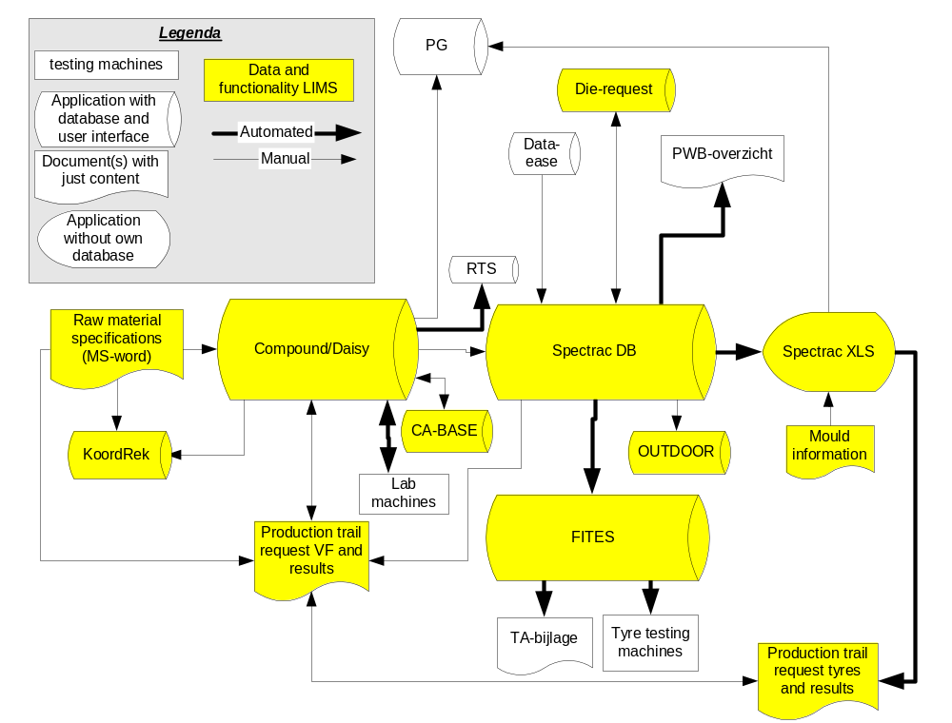

Product specifications

Introduction

Process
Vredestein delivers tyres as the end product. However, as Vredestein has it’s own production location, all levels of semi-finished products to raw materials can be distinguished. All these products and materials are called article within Vredestein. For these articles four article types with their typical sub-types (not complete in the following example) can distinguished:
- Raw materials
- Reinforcement materials
  - Cords
  - Fabrics
  - Wires
- Polymers
  - SBR's
  - BR’s
  - NR’s
- Fillers
  - Carbon blacks
  - Silica’s
  - White fillers
- Production additives
- Compounds
- Final mix
  - Sidewall compound
  - Tread compound
- Master batch
  - Sidewall compound
  - Tread compound
- Semi-finished product
- Extrudate
  - Sidewall extrudate
  - Tread extrudate
  - Heel filler extrudate
- Calandred compound
- Ply (calandered cord/fabric material)
- Assemblies
  - Green tyre
  - Pre assembly
  - Heel
- Tyres
- Passenger car tyre
  - Winter
  - Summer
  - All season
- Agricultural
  - Tractor Front
  - Tractor Rear
  - Implement
  - Spacemaster (foldable spare)
- Industrial tyres

An article is defined by a set of parameters. Two type of parameters can be distinguished:
- parameters defining how to manufacture an article (the recipe)
- parameters how the article should look like (the specification).

Dependent on where in the Vredestein organization (TCE or production) and Vredestein process you look, a different parameter set is relevant in defining the article. In the figure below this is represented in a data model.
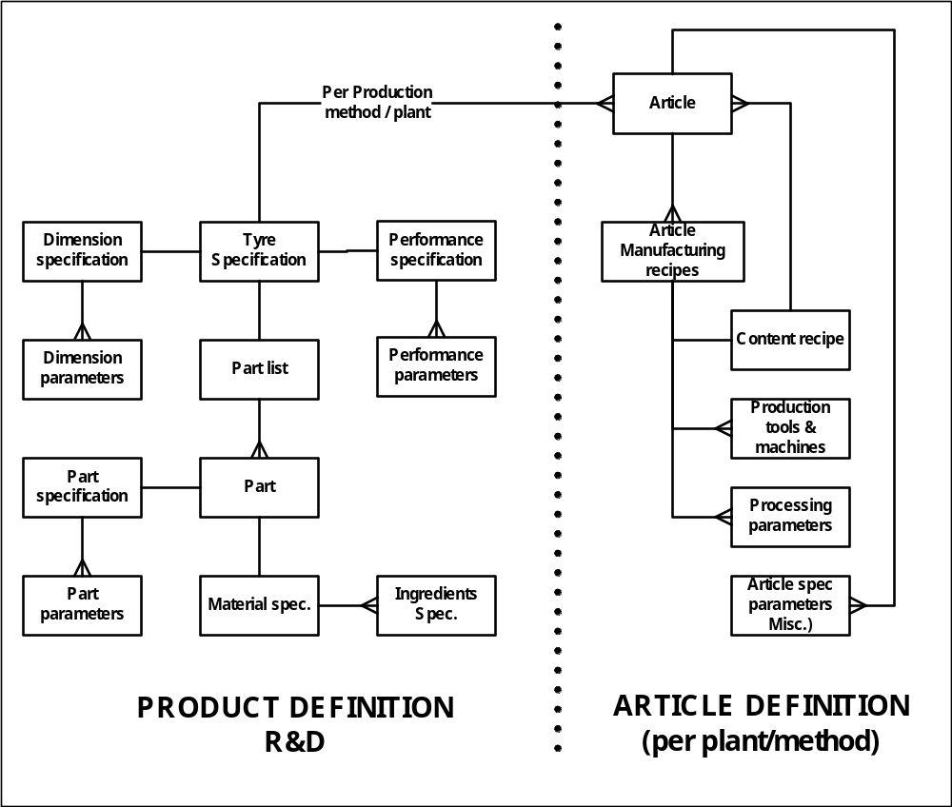

Entity | Description / definition
Article | An unique physical product or semi finished product or ingredient in one production plant.
Tyre specification | A specification of the article which is independent from the manufacturing method
Dimension specification | The measures of a section of the tyre.
Performance specification | The specifications of the performance of the tyre on a car (high speed performance, endurance, aqua planning, breaking distance etc.)
Part list | A tyre consists of several tyre parts, which are the content of a tyre
Part specification | A part is a region in a cross-section of the tyre containing one homogeneous material (Upper thread, Under tread, Sidewall-rim side, ply layer). Per part several parameters can be specified.
Material specification | Specification of the homogeneous material within one part.
Article manufacturing recipes | One article can be produced by several manufacturing methods/plants each having their own manufacturing recipe.
Content recipes | Each article does have a Bill of Material in the manufacturing systems with sub-articles which can have their own Bill of Material
Production tools & machines | Tools in the manufacturing required for the manufacturing of this specifications (moulds and dies etc.)
Processing parameters | Specification of process parameters like temperature, pressure, line speed etc.)
Article spec. parameters (Miscellaneous) | Several parameters to be specified per production method/plant.

In the R&D environment relations exist between test results and:
- other test results on the same sample
- the target values in the dimension specification of the sample’s article code
- the article recipe
- The information 1 to three from the sub articles / sub samples the sample is made of

In the article definition most articles are created from other articles (via the article recipe). Starting at the highest level (tyre), one can visualize this as a tree. For a tyre can this tree typically looks like (the colors refer to the explanation of article types):

Tyre code (Vulcanized product)
Greentyre code
Pre-assembly code
Innerliner code
Compound code
Vulcanisation chemical 1 code
Vulcanisation chemical 2 code
Vulcanisation chemical 3 code
Rubber 1 code
Rubber 2 code
Rubber 3 code
Filler 1 code
Filler 2 code
Filler 3 code
Sidewall extrudate code
Sidewall compound
Like innerliner compound code
Rim compound
Like innerliner compound code
Ply code
Plycord code
Ply compound code
Like innerliner compound code
ETC.

However, for a different building process or production plant this can be a different tree representing the same tyre. Difficulty with the tree is that it has a variable depth, which is depending on the semi-finished product used, and the building method used.

Current situation
In the development of a tyre one can roughly say that SPECTRAC XLS and SPECTRAC DB work with the information till the compound/ply code level. The compound/ply codes to raw material relations exist in the COMPOUND and KOORDREK system. In SPECTRAC DB, the available compound/ply codes are maintained manually with information from COMPOUND and KOORDREK.
After the development of a tyre a production recipe is created (manually) in PG. Modifications in the recipe are authorised by a CP (change letter) and/or a TA (Technical authorisation). This modification has to be altered in both PG and SPECTRAC/ COMPOUND.

New situation
The complete tree from tyre to raw material is available in one system, so tests results can be easily (cor-)related and reported.

General

Data storage

Current situation
Multiple systems hold the same data, or refer to data by re-typing a code, while no access to the underlying data is available. Typically also the data, tolerances and control plan data on the same article is fragmented into different systems.

New system
All relevant article definition data is stored in the LIMS and available on the article:
- Specification (including tolerances). Defaults for the tolerances are provided by the LIMS.
- Control plan (frequencies with which the parameters in the specification have to be checked)
- Recipe(s) (including tolerances and relevant processing and machine information)
- User interfaces to update the information in the LIMS. These interfaces are based on the currently used interfaces from:
  - SPECTRAC DB
  - COMPOUND
  - KOORDREK
- For the (green-)tyre maintenance the user interface of the current SPECTRAC XLS can be used. In order to create an interface between this sheet and the LIMS-database, a certain data structure is necessary. This data structure can also be used to cover the COMPOUND and KOORDREK functionalities regarding specifications. This interface is described in the appendix.
- Different roles can be responsible for one article definition. This is supported by the LIMS.
- R&D information on manufacturing tools is defined only once (see requests chapter on tooling manufacturing request) and interfaced to or from the LIMS system.
- The article definition from the LIMS is interfaced to the PG system (AS400-database) and can be interfaced to our Mixer control system (Oracle database).
- Vredestein has to take care that the specification parameters of an article are closely related to competitor analysis test methods

Control plan

Process
To validate the quality level of articles in the production, the specifications of the articles are checked on regular basis. This regular basis is dependent on the article. A typical example of a control plan is shown in the figure below.

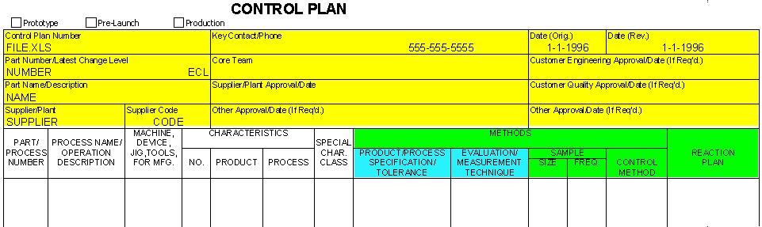 Current situation
A formal control plan does not exist. In approval documents (TAs) and SOPs these tests and there frequency are mentioned.

New situation
A control plan for an article can be reported from the LIMS. All data to report a control plan can be maintained on the article. The yellow fields in the figure are typical header and approval data on the article. The blue fields are reflecting the specifications and the green part are specific control plan fields. The reaction plan has to be a valid value in a lookup table.

Not all tests can be planned from the LIMS because:
- LIMS does not plan the production
- Not all test result storage is in scope for the LIMS
Therefore LIMS only makes request on basis of the control plan if:
- The frequency is in time interval units.
- The test method is one that is active in the LIMS system
- The LIMS is triggered by another system or person
In that situation the LIMS has to take action and depending on the frequency requests are created that initiates sampling and doing the appropriate tests. When the article is out of limits the work flow in the reaction plan has to be activated.

Calculations

Process
In order to specify articles in a common and efficient way, the user needs help in the maintenance screens.

Current situation
The SPECTRAC XLS, COMPOUND and KOORDREK program contain calculations to obtain new values or to propose values. Also validations for several parameters are available. Most of these calculations are simple mathematic and logic operations. SPECTRAC XLS sometimes uses a table lookup. Using the SPECTRAC XLS is a flexible user interface can easy be updated by a responsible specialist if extra functionality is needed.

New situation
- The calculations from the COMPOUND and KOORDREK program are integrated in the interfaces.
- The SPECTRAC XLS front-end may stay and has to be extended to cover new building methods and agricultural specifications (Vredestein responsibility). If the interface is integrated in the LIMS, the maintenance of the calculations and algorithms can take place without hiring an external party.
- (multiple) parameters can be retrieved from one table lookup.
- Validation on input fields should be possible
- The (material) costs of an article can be calculated from the raw materials used in the article using the complete article tree.

Coding / relations

Current situation
Articles are specified without using explicit version numbering. This means that a complete article code is the concatenation of the common article code and a version number. For tyres only a common article code exists and old versions are stored in a history table. From the date in the history table the version history can be derived.

New situation
- Uniform version numbering policy for all articles
- Changing a recipe or specification changes the article version, but the relations of the article to other articles stays intact.
- Vredestein has to take care that the version management is in line with the version management in the production plant.
- Vredestein has to decide on new coding of the trial articles.
- Article code for Product definition and article definitions can be different
- It must be possible to generate a new version of an article without changing the currently approved version.
- It must be possible to find the version and the details of that version using a data, i.e. what was the active version of XYZ on date …?
- It should be mandatory to create a new version of an article that is changed. The fact that there is a change pending on an intermediate product should be visible on the end product.
- It should be possible to approve new versions.

Article status

Current situation
No uniform status are defined for articles.

New situation
Articles should have uniform status typically representing:
- input
- trial
- production
- out-of-production
For an ordered amount of an article these status typically
- input
- experimental
- ordered
- available
- removed
It should be possible to change groups of articles in a status.

Grouping

Process
As explained in the introduction section, several article types and sub article types can be distinguished.

Current situation
Because of the different systems, the data is automatically grouped.

New situation
Because all is now in one database
- the data has to be grouped on the top level (article type) and the existing sub article types in the current systems.
- easy grouping on plants should be available
- per production plant authorization could be set on maintaining the article definitions.

Article tree

Current situation
In the PG application it is possible to get a tree-like view of the structure of an article.

New situation
A tree like structure of articles and sub-articles and other recipe parameters is visible and maintainable in the LIMS. This tree can shown as a tree as well as a flat structure, containing all information till the raw material level. On these structures a diff-function can high-light the differences between two article definitions

Authorization

Current situation
A (tri-)TA document is created in our document archive “doc-lib” with all the article definition information of the article(s) to be approved. This is combined with supportive information (like test results on an article) and argumentation. The FITES system has a report facility to create the necessary information for the TA document. For some article definition information the TA-document is the unique source of information. The TA document goes through an approval cycle in the “doc-lib” system. When the approval is given, manually the article definitions in the different systems are created/adjusted

New situation
- The LIMS has functionality to report the required article definitions and test results for the TA (see chapter on reporting)
- A Tri-TA is valid for a certain time. The LIMS should have the functionality to show all Tri-TA's and articles which have passed validty date.
- The approval process may stay in Doclib. A mass status update is possible on articles with a hyperlink to the TA document.
- The mass status update triggers a export process to the PG system and the mixer control system.
- Process engineers may activate the new version of a manufacturing specification by importing the new data from LIMS into PG or Mixer Control at any suitable moment. This import function must be realized by Vredestein. LIMS must be able to fill data into an interface file when new versions are approved.

Raw materials

Coding

Process
As explained in the introduction section, several article types and sub article types can be distnghuished
Raw material for use in specification, purchase, certificate control and in trial compounds is uniquely defined by:
- raw material code
- Supplier
- Supplier production plant
- Packaging

Current situation
This is “solved” by article coding definitions.

New situation
this hierarchy is clearly defined in the database.

Reporting

Current situation
A word document has to be typed to make a raw material specification and overviews of the raw materials exist in “proefgrondstoffen.xls” and “actueel.xls”

New situation
The raw material specification document is generated by the LIMS.

Compounds

Processing data

Process
Compound recipes can consist of raw materials and/or other (master batch) compounds. Besides the ingredients, the processing of a recipe has large influence on the properties.

Current situation
Processing information is/can not be stored on a recipe.

New situation
Processing information can be stored on a recipe.

Retour information

Current situation
Tolerances on the recipe, and “rules” to improve process ability or to workaway waist products are/can not be stored on the recipe in the COMPOUND system.

New situation
In the LIMS this information is stored in the recipe

Compounds with trial raw materials

Current situation
Special functionality in the COMPOUND system exists that replaces a trial code in the current raw material code in old recipes.

New situation
It is clear in the old recipes which current raw material code is used.

Reinforcement material

Process
For reinforcement materials the raw material does exist at the supplier and we buy a pre-processed material in the form of a fabric. However the cord information (a non existing entity in the production plant) has to be store in the ply and tyre specification, while the fabric is input in the ply and tyre recipe.

Current situation
We can easily work-around this inconsistency because we have multiple systems and the supplier specification is just a word document.

New situation
we need to be able to generate a specification for the supplier that describes the fabric and the recipes referring to the fabric, while in the tire and ply specification we refer to the cords used.

Semi-finished products

Current situation
Currently at the R&D level, not all semi-finished products are known in the system. Also in trials semi-finished products are requested explicitly, so we have no article codes available to store tests on. At the production level all semi finished products aswell all the relevant processing information is available from PG.

New situation
Semi finished products are defined in the LIMS. Vredestein has to decide how to cope with the (trial-)coding of semi-finished products.

(green-) Tyre

Current situation
Different solutions are used for agricultural and SpaceMaster tyres and passenger car tyre tyres. The specification of the semi-finished products aswell of some of the processing information is stored the "standard specification". The standard specification is derived from SPECTRAC. The dimensions of the tyre are stored in a dimension specification also generated from SPECTRAC XLS.

New situation
There should be a generic solution for tyres, where passenger car tyre, agricultural, industrial and SpaceMaster are four flavors.
- The solution should support/integrate the E-keur request process
- The mould parameters have to be stored in the LIMS and exported to CATIA
- Vredestein has to take care of a coding procedure for hand cut tyres
- More points for improvement where Vredestein can look into are:
- Support for the size-extension process (CATIA/common support tool)
- Clean up the calculations by defining common building machine parameters

Possible datamodel
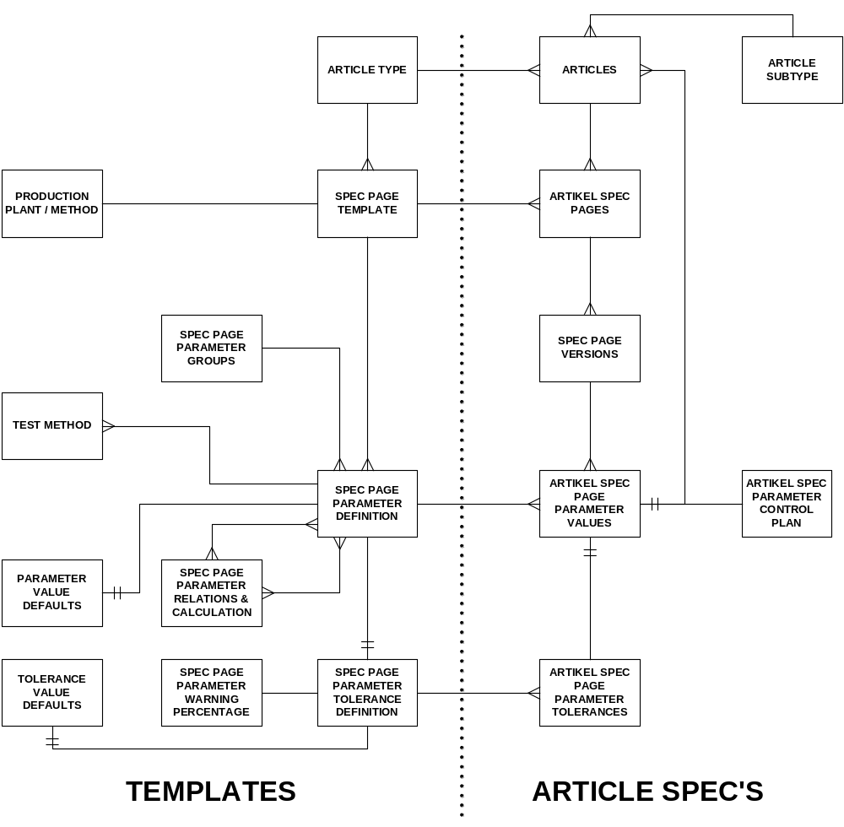

Entity | Description / definition
SPECIFICATION TEMPLATES

Article type | Articles having the same manner of specifications are combined into one article type (Tyres, greentyres, treads, sidewalls etc).
Spec page template & production plant / method | The specification template contains several pages. Example: One page for a standard product specification which is manufacturing method independent (R&D-spec). One page for each manufacturing specification per manufacturing method (APBM, HAPBM, YAZD, AMTEL etc.).
Spec page parameter definition | On each page several parameters can be specified. A parameter can be of the type:  - Value  - Text  - Sub article type (Treads, sidewalls)  - Lookup value in value table using a predefined filter (on group etc.).  - Link to a file (drawing, picture etc.)
Test method | A certain parameter can be tested via several test methods. The final link is made during the definition of test methods (See also paragraph “Testing”).
Spec page parameter tolerance definition | Per parameter one set of tolerance boundaries (Tol + and Tol -) can be defined (optional)
Spec page parameter warning percentage | Per parameter a certain percentage can be defined for warning limits in relation to the tolerance limits. So it will not be necessary to define these warning limits per article. (example: for all articles the warning limit of parameter X is 70 % of the tolerance limits)
Spec page parameter groups | Spec parameters can be assigned to parameter groups used for reporting, workflow and authorization within R&D (Group Production tools, Machines, Process parameters etc.)
Spec page parameter relations & calculations | It must be possible to define calculations using parameters as input. The output of these calculations can be assigned to other parameters
ARTICLE SPECIFICATIONS

Article | Article can be a physical product, physical sub products (semi finished products) or logical parts within a physical product.
Article subtype | Articles within one article type can be assigned to several subtypes used for “table lookup filtering”, reporting, workflow and authorization within R&D. Example: Article type “compounds” can be divided into “Tread compounds”, “Sidewall compounds” etc.
Article spec pages | Each article specification consists of several spec pages with parameter values according to the defined template.
Spec page versions | When an article specification page has to be changed a new version of the related production article and his specification will be created. This new specification has to be approved and authorized (several stages) in order to become the actual version (just one actual version can exist). Besides a version number also a reference to a modification document must be registered. When the modification takes place on a sub-article, also all final products containing this sub-article must get a new version with a reference to the same modification document. The versioning mechanism is not valid for every spec. parameter (per parameter on/off switch able). Changing a description should not lead to a new version.
Article spec page parameter values | Each spec page can contain several specification parameters & values for this article.
Article spec page parameter tolerance values | Each parameter can have tolerance values (optional).
Spec parameter control plan | For each parameter a desired sampling and testing frequency can be defined during normal manufacturing stage. Frequency can be on “X times per unit of time” or “Once after manufacturing amount X”. This data can be interfaced to the production scheduling system in order to schedule sample taking during the manufacturing process. The samples will be registered into LIMS, it will be possible to check the actual sample testing with the control plan.

Using parameters of the type “Sub article”, a tree structure of articles and sub articles can be created. These structure must be visible and maintainable in a tree-view like the windows explorer (adding new parameter definitions). During development of a certain product it is only possible to link an existing article code to the parameter of type “sub-article”, which must belong to the defined article type. Also this sub-article can have it’s own spec pages with parameters.

Requests

General

Process
Requests or workordersare created from within a project definition as defined in the long range plan or without a project definition as for troubleshooting requests; claim requests or other similar requests. Creation of “fictive” projects is possible if having a constant hierarchy is beneficial for the system. A request will start research activities, the production of pilot articles, production tools or testing. A request is normally initiated by a specialist in the R&D department or production.
In a request, three types of requests can be distinguished (see figure below). A request can consist of multiple requests of one or more these different types:
- Production tool manufacturing request.
This is used for obtaining production tooling in order to be able to produce a certain article.
- Manufacturing request
This is used for manufacturing articles in the laboratory, in the production plant or to get (buy) articles from a third party.
- Testing request
This is used to define testing to be performed on an article sample or on the material of which (a part of) an article sample is made. Preparation and/or ageing activities may be defined in this request type.

Figure 1: Example break down scheme of requests. A request can be a combination of more than one request type.
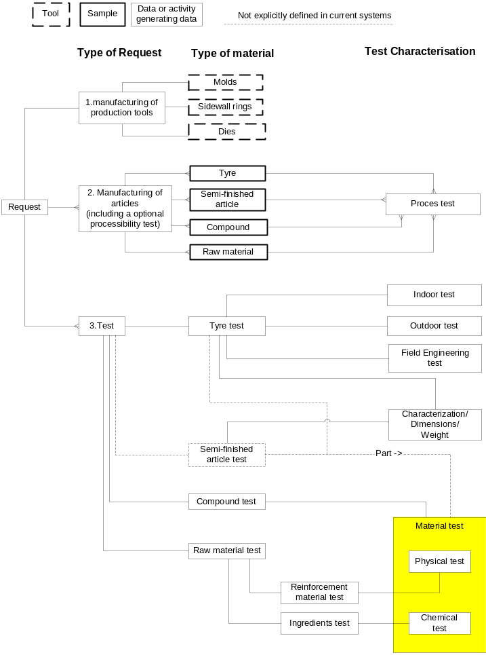

The reason for an article manufacturing request can be twofold:
- Obtain a physical article (sample) to test
- Test the manufacturing of an article recipe
In most situations both options are used simultaneously. Before the article can be manufactured the production tools need to be available. Therefore the manufacturing production tools request needs to finish before (a processing step in) an article manufacturing request can be started.
When the sample manufacturing is finished, a test request on that sample can start. The sample is transported to the correct location and the test can be performed. The article manufacturing request is only in scope in case of trial articles. Test request can however also be created on production material of which the manufacturing was not initiated from the R&D department.

Current situation
The requests are handled by multiple systems. Data has to be retyped in other (definition/ test) systems and multiple requesting systems have to be consulted to obtain the status of the related requests. The systems have their own specific process flow and use slightly different definitions. People need to learn to use multiple systems and it obstructs job rotation.

New situation
- The requests are handled in LIMS in a uniform process flow that is similar for the different request types.
- A sample can appear in more than one request. In the LIMS a unique reference to that sample exists.
- A test request on an sub sample (one specific tyre) of a manufacturing request created before the manufacturing request has started. Which specific sub sample has to be tested can be decided later on after some non-destructive tests on (all) sub samples
- A request typically contains the following general (header) information:
- A request number
- Reference number f.i.
- Trial program code
- Claim number
- Troubleshooting number
- Competitor trial series number
- disposition code
- chargeID
- etc
- Project code
- Requester
- Budget number (is derived from the project code)
- per test/article requested ready date(s)
- per test a priority
- aim of the request
- Templates: In the current situation every request has to be build from scratch again. However, common practice is that an old request is copy-pasted. In practice this is a source of errors. In the new situation templates with common trial series and manufacturing programs are available to handle standard situations. The activities to perform are depending on the article type, article subtype and trial program type.

Production tool creation request

Process
Production tools are needed to manufacture articles. In the recipe of an article, production tools are specified. The specification of the production tools is dependent on some definition parameters of the article one wants to produce with it. The code of the production tool is to be used in the article recipe.

Current situation
Every type of tool has it’s own request handling. For moulds and sidewall rings the information is communicated per e-mail. For dies an excel application is used as the database and to create a request document. The information used in the request has to be re-entered in the SPECTRAC DB application.

New situation
The production tool manufacturing request is integrated in the LIMS. The code of the tool and the relevant definition parameters of the article or tool is reported from the LIMS. Because every tool has it’s specific needs, no generic solutions exists. The exact parameters to transfer are dependent of the tool.

Internal request
For a request that is designated to another LIMS user, the information to them is available from the LIMS. Workflow need to be setup so the creation of request triggers the correct people. Finishing activities will result in status update an triggering the next step.

External requests
For a request that is designated for people that don’t have access to the LIMS, the LIMS should produce (part of) the information to be send to the third party. This can be by the creation of a word document or e-mail. The most important information LIMS has to provide for manufacturing tools request is the specification of the tool or the specification of the article to be manufactured by the tool.

Article manufacturing request

Process
Particularly if the articles are produced at Vredestein, processing characteristics are important. Because the aim of the manufacturing in most cases is to obtain the properties of an article, this type of request often is closely related with a testing request. Depending on the type of article and the amount, the articles are manufactured in the laboratory (compounds), in the production plant or outside of Vredestein (typically for raw materials). Typically in one manufacturing request different “variants” are manufactured in the same “run”.

Current situation
The article manufacturing requests are created in SPECTRAC XLS, COMPOUND, and excel-sheets (with a standardized lay-out). In which system the requests are stored is dependent on the article type, and the amount of articles. In some cases the definition of the article is available in the system that stores the request.

New situation
All the article manufacturing requests are stored in the LIMS, and have the article definition available in the worklist for the operator. Per request more than one variants of an article can be requested.

Typical extra information to store per article in the article list:
- article code
- article recipe
- article specification
- amount
- storage information
  - time
  - where
- required processing information
- disposal/workaway options

Internal request
For a request that is designated to another LIMS user, the information to them is available from the LIMS. Workflow need to be setup so the creation of request triggers the correct people. Finishing activities will result in status update an triggering the next step.
Internal request will handle all trial manufacturing our own production plant or laboratories and buying competitor tyres.

External requests
For a request that is designated for people that don’t have access to the LIMS, the LIMS should produce (part of) the information to be send to the third party. This can be by creation of a word document or e-mail. The most important information LIMS has to provide are
- the complete article specification
- a Vredestein article code
- an amount.
External request will be created to order trial raw materials.

Testing request

Process
A testing request defines the testing to be performed on an article or on the material of which (a part of) an article is made. This article could undergo a preparation or ageing before testing. Preparation and ageing other than the default are specified by the requester.
Testing is also performed as routine production control. In this case production articles are tested with a certain frequency in order to monitor the production quality.

Current situation
Test requests are created in COMPOUND, FITES (most of the indoor testing of tires), or by private communication (most other tyre tests). The request and the results of testing that is related to processing or performed in the manufacturing facility is stored in the manufacturing request excel files or are arranged by private communication.
In COMPOUND a pure testing request can be created, or a combined manufacturing and testing request. In COMPOUND, a recipe code, preparation, ageing and a test code define a test.
In FITES, a request handles the testing of one or more sets of tires on a certain test code using certain test conditions (tyre pressure, environmental temperature etc.). FITES has limited options to define preparation or ageing (tyre pressure, load). FITES and COMPOUND need a request to store results. For production control this implies that manually requests need have to be generated, depending on information stored elsewhere.

New Situation
- All testing requests are stored and handled in the LIMS system.
- Tests can only be performed on certain article types. When a request is created for a test on a certain article type, only tests can be selected that are valid for that article type.
- The LIMS automatically creates requests from the control plan, when tests are within the scope of LIMS.
- The LIMS allows easy entry of test results for production control (preferably without the need of creating a request)
- The system allows easy initialization in the LIMS database for CLAIMS and TROUBLESHOOTING activities and a clear overview the results, grouped by CLAIMS and TROUBLESHOOTING.
- Requesting a standard test is be possible with only a single code. Default values in preparation, aging, conditions and testing are used.
- It is easy to request a test with ageing, preparation, test conditions and other settings than the default. The results of these results should not be mixed with results with the standard settings.

Typical information to store per article to be tested:
- Sample code (can be reference to a manufacturing request)
- part of the article on which the test has to be performed (when applicable. This is not explicitly specified in the current situation)
- test code
- preparation method (see chapter on testing)
- aging method (see chapter on testing)
- test conditions
- alternative settings (when applicable. This is not possible in the current situation)
- Extra text fields for standard scientific reporting (see chapter analyses/reporting)

External requests
When a test request has to be made for a new third party test, a test method/department has to be created. When that exist, requesting an external test is for the requester similar to requesting a internal test. The request is routed to a responsible person for that test method/department combination and request and tests are set to an appropriate status. The material and order are send to the external testing instance. When the results come back, the information is imported in the LIMS and the status set to “ready”, and the normal workflow like for the internal order. Because the test instance is stored on the test method, the status of external testing does not mix up with the work of the Vredestein test laboratories

Possible data model
In order to clarify the above paragraphs a possible data model is given in the following figure.
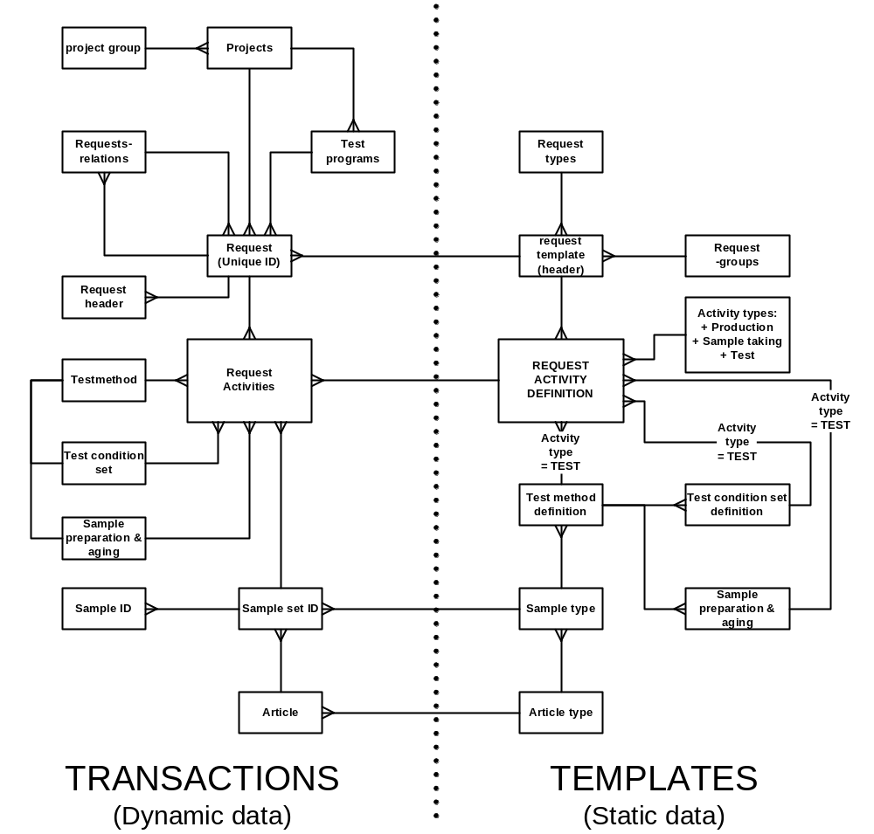

Entity | Description / definition
Projects | Projects regarding development of new tyres or new materials to be used in existing and/or new tyres
Project groups | Projects may be assigned to project groups (optional) for reporting and authorization purposes
Test programm | A sequence of requests to be carried out during a project. More trial series can be carried out in parallel.
Requests | A set of activities to be carried out which can be seen as a logical bunch of work. Requests can be triggered in several ways:  - Time driven (scheduled in time)  - Event driven:  - Registry of a sample  - Completion of a requestactivity  - Dependent on some test result
Requestrelations | Requests may be related to other requests (incidentally)
Requestheader | Requestgeneral data like: instructor, worker, scheduled starting date, etc.
Requestactivities | Within one request several activities can be defined. Activities can be of type:  - Manufacturing of sample material  - Sample taking out of produced material  - Testing of samples  - Stocking samples on certain locations or scrapping.
Sample set ID | A requestactivity is related to one sample set ID. A Sample set is an amount of identical samples of the same article code / manufacturing charge (4 equal tyres on a car, 3 samples taken out of a roll of ply etc.)
Sample ID | The identical samples within a sample set do have their own unique identity.
Test method | A activity of type “Test” is related to one test method to be carried out on the specified samples
Sample preparation & aging | Before doing the specified test, a specific preparation of the sample may be specified. This preparation method must be relevant for the specified test.
Test condition set | A requestactivity of type “Test” is related to one set of test conditions which have to be set during the test of the samples (tyre pressure and environmental temperature during a high speed test)
Article | A physical product where we can take samples of for testing. The article code belongs to a specific production method/plant.
Article type | Articles having the same manner of specifications are combined into one article type (Tyres, greentyres, threads, sidewalls etc).
Sample type | One article can deliver several kinds of samples. From article “tyre” we can take as a sample:  - The hole tyre  - A cross-section of the tyre  - A punched part of the tread  - Etc.

TEMPLATES FOR REQUESTS

Request types | Per type of work several requesttemplates can be defined.
Request groups | Requests of a certain request type can be divided into several request groups. In the template default group codes can be assigned.
Request template | Per request type a template for the header can be specified. After creation of an unique request of this type the general header data must be filled in by the instructor (optional pre filled with some defaults)
Activity types | Activities can be of type:  - Manufacturing of sample material  - Sample taking out of produced material  - Testing of samples  - Stocking samples on certain locations or scrapping them.
Request activity definition | Per request type a set of default activities can be specified. After creation of an unique request of this request type, these activities are copied to this request (including default settings). All request parameters can be changed manually after creation.
Test method definition | A request activity of the type “test” must be assigned to a specific default test method.
Sample preparation & aging | Selecting a test method will reduce the possible sample preparations. Within a request activity definition, one preparation may be selected amongst the possibilities for the selected test method.
Test condition set def. | A specific default set of test conditions may be assigned to a request activity of the type “test”. Selecting a test method will reduce the possible condition sets. Just one set may be selected in one activity of type “test”.

Workload analysis can be done by using the durations per activity type and the capacity of the test equipment (see paragraph test).

Article manufacturing and testing

Introduction
In this chapter, the testing and article manufacturing related activities of the involved departments are analyzed. This means all the activities starting from the request of article manufacturing to the storing from the data in the LIMS database.

This chapter is divided into three main sections:
- Article manufacturing
- Testing
- Laboratory supporting processes

Article manufacturing

Process
Starting from an article manufacturing request, articles are manufactured in the materials laboratory or in a production plant. It is also possible that the articles have to be acquired from a third party. In the following table the different possibilities are shown.

 | Tyres | Semi-finished products | Compounds | Raw materials
Production | X | X | X
Materials laboratory |  | X | X
Externally | X | X | X | x

From the requests and the definition a worklist is generated in which specifically is described how the articles should be manufactured. Relevant processing information during the manufacturing is logged. For example during the production of a compound the mixer fingerprint is stored or the scrap rate after vulcanization of a tyre is logged.

Current situation
Depending on the article type, the worklists are generated in COMPOUND and exist in several excel files. Relevant processing data is in these excel files not easily retrieved.

New situation
The LIMS should eliminate all the existing TCE applications used for article manufacturing. When applicable, from the request in LIMS a worklist is generated which can be used by the operator to manufacture the article sample. In the case of manufacturing outside of Vredestein the worklist should be in such a form that it is ready to be sent.

Testing

Process
In a test request a request is done to perform a test on an article sample or on a sample of part of an article sample. In some cases a test consists of testing one sample or in other cases of testing multiple samples. For instance the handling of a tyre is tested on 4 tyres mounted on a car. Wet skid resistance however is determined on two tyres.

In the appendix an overview is given of the different sample types which can be identified and the relations between them.

In some situations from the request a worklist is generated with which the test operator has a clear overview of the test settings and a space to write down the test results.

Before the actual testing, it is sometimes necessary to prepare the sample. For instance in order to test the tensile strength of a rubber compound, the material is shaped and vulcanized before testing. Or in the case of tyre testing the tyre has to be fitted on a rim, inflated and conditioned. Besides the preparation, in some cases a sample is aged. This means the sample is subjected to a certain temperature and environment for some time in order to study the long term behavior. The preparation and aging of a sample has a large influence on the properties of the material so it is evident that this information is coupled with the test.

From the request, specifications and test procedure the test instrument is setup. Tests can be performed under varying conditions. In most cases the standard test settings are independent of the article to be tested. However in some cases the default conditions are dependent on the article. For instance the load with which a tyre is pressed to a test drum is dependant on the size and type of the tyre.

Besides standardized tests in which the preparation, aging and test conditions have a default value for a specific article, one can also distinguish research testing. In research testing preparation, aging and test settings can be varied. For a specific type of test one can distinguish the general test conditions and the (variable) test settings. As an example in a tensile test the shape of the test specimen is a general condition but the temperature and speed of the test are variable.

After testing, the results are validated by the test operator and stored in a database. In some cases the raw data has to be modified to obtain the end results.

Numeric simulation can be regarded as a test. The model can be regarded as an article sample and the outcome of the simulation as test results.

Current situation
Test related information is stored in many different systems or as hardcopy. Information can be found in standard operating procedures (SOP), local systems (instrument PC), global systems (COMPOUND/FITES/OUTDOOR) or in MS word/excel files.

In some situations the instruments are linked to global systems (see chapter on current software systems). With a few exceptions (see appendix) the interface only consists of automatically storing the test data in global systems by means of file transfer. When no link exists the, the results are processed manually in the global systems, or the data is reported using MS-WORD or MS-EXCEL files. It is not possible to store images, graphs (except for COMPOUND) or other information. In appendix an overview is given of the test instruments and the interfaces.

The majority of the tests which are performed are standardized tests. These test are defined by a single code. Some preparation, aging and general test conditions are stored in SOP's and other in global systems (FITES, COMPOUND).

Requesting a research test is not possible or very difficult as is a uniform storage of the results. Test procedures can evolve. At this moment it is not possible to trace the history of a test procedures.

New situation
The current systems are eliminated. All the test related data is stored or accessible via LIMS.

Test method
In LIMS a test method contains at least:
- Test (sub)type (group)
- Version number and version date
- Responsible test engineer
- Standard operating procedure
- ISO/ASTM reference
- test status

Instrument interfacing
- Test instrument files can be initialized from the LIMS in order to load the correct parameter file. (nice to have feature)
- Test results are stored automatically in the LIMS database when possible or by manual input (see appendix for more information).
- Raw data from a test is stored on a file server and is accessible by a file (hyper)link

User interface
The LIMS should have a user friendly, uniform interface for test procedure, initialization, results entry, result display and (in)validation. Bar codes can be used to minimize typing at some locations. Only relevant information (result fields, samples) should be visible for operator and specialists.
Standard testing:
- Default values in preparation, aging and testing are available for the operator. These values can be dependant on certain article parameters.
- Test operators are provided only with the relevant data.
- SOP's should be available via a file link (MS-word file)
Research testing:
- It is possible to store test results with non-standard preparation, aging and test conditions. Test results should not be mixed with the standard test results.
- Test operators should be provided with a clear overview of the different conditions.

Test results
Test results are stored in or linked to by the LIMS system.
The following result types can be stored:

Table 1: The result types to store
Result type | Remark
Text | Free text
Numeric | Real and integer
Boolean | Yes/No, True/False, red/black, i.e. always the choice between two options.
Graph | It should be possible to compare graphs within the LIMS sytem.  The X-axis of the graph is dynamic.
List | One value to pick from a list (for instance good, acceptable, bad)
Sound files | File (hyper)link
Photo’s/video's | File (hyper)link
Raw data | File (hyper)link

- From a test result the following information is available:
  - Sample preparation of the article before testing.
  - Ageing of the sample(s) before testing.
  - Specific test settings (the condition(s) with which the test is performed).
  - Other tests performed on the same sample
- The LIMS system is able to perform calculations on the results in order to obtain the end result. It should be possible to recalculate results of already tested tests when there is a change in the calculation definition.
- In adhesion testing, the adhesion is measured between two materials. These two materials can be rubber-rubber, cord-rubber or fabric-rubber. It would be advantageous if the results of all tests can be retrieved by searching on one of the both materials.
- Validation of results
Results of a test should be automatically checked with the limits as given in the specification (when applicable). It should be possible to define an event following a pass or fail result (e.g. email in case of a Coa check). In case of an invalid measurement a retest can be performed. This retest can be recognized in the system.
- A test result can have the following statuses:
- Not tested: Sample is not tested
- Tested: Sample is tested, no limits are available
- Pass: Test results are within limits
- Warning: Test result are outside warning limits but within final limits
- Fail: The test result are outside final limits
- Ignore: The test result should be ignored. This status is set manually by the tester.
- In the LIMS the tracking and tracing information (for instance chargeID) available from the plant is registered on the sample.

Multiple tests on one sample
- In some situation several tests are performed on a sample. This can be sequential but also parallel. (e.g. sequential: “hardness” testing after endurance testing; a photo after handling testing or parallel a thermographic scan during a high speed test). In the LIMS it is easy to request these sequential and parallel tests and store the data in such a way that the individual test results are still available for comparison. The test results of sequential tests can be distinguished from test results on fresh samples.
- When a tests is changing the properties of the sample and when a test result is obtained in a sequential test following a property changing test, the user is warned that the latter test results on the samples are not to be compared with fresh ones.

Multiple samples for one test
Especially in tyre testing, testresults are related to a reference value. For instance in wet skid testing a test result can be 102. This means the tested sample is 2 % better than the reference value. The LIMS should be able to store the data and the link to the reference should be available. (102 means nothing if the reference is unknown)

Testing in different laboratories
Similar tests can be performed in different laboratories on the same sample types. The same test methods performed on different locations should be easiliy compared.

Laboratory supporting processes
Besides the primary task of testing in the laboratory a few other, supporting processing can be distinguished:
- Workflow management
- Test equipment calibration/maintanance
- Sample storage

Workflow management

Process
To provide requesters with an overview of the status of a request and to plan activities on the different laboratories and production facilities, an overview is needed of current and (near) future workload.

Current situation
This information is retrieved from the different systems or from private communication. Typically planning sheets are created in excel, where the format is dependent on the laboratory/production plant. There is no direct support for workflow.

New situation
The system allows us to:
- create an overview of request/activities typically on a combination of project; request type; laboratory type; Testinstrument type; requester identity; date period; priority, status, so everyone can get a relevant overview.
- Planning of activities within a laboratory
- This overview should be exportable and automatically generated.
- Test request can be created on articles that still have to be created.
- Functionality must exist to link the expected ready from a former step to an expected start date from the next step. For example if a production trial is delayed for a week the expected ready date is also delayed for two weeks.
- A status mechanism can be used to register and visualize the progress of the workflow within a request.

Lang term planning of outdoor testing is out of scope of the project.

Worklists

Current situation
In some cases a worklist is created with information from the request, specification, test equipment and test procedure. The worklist contains useful information for the tester in order to accurately perform the test or to write down test results.

New situation
The worklists are generated automatically from the LIMS. From a request an overview is available of the status of the different activities. In this overview the logical workflow is taken in consideration (e.g. manufacturing, preparation, aging, testing)

Test and manufacturing equipment calibration and maintenance

Current situation
The technical information and calibration of the test and manufacturing equipment is under supervision of our engineering department. The test results of the calibrations is stored partly in excel sheets at the engineering’s department and partly in Compound/daisy and APPLAB.

New situation
Equipment can be defined in the LIMS system and some general properties of the equipment should be stored. The LIMS system monitors the calibration and maintanance status of the equipment and provides a signal when an instrument is due for a calibration(check) or maintenance. Calibration and maintenace can be triggered on a time interval but also on the number of tests performed on the instrument. For instance the allignement of a car (=instrument) should be performed every X km.
Calibration(checks) can be stored in the LIMS database and an automatic validation takes place.

Long term sample storage

Process
Some test materials and test tyres are stored in freezers or at other storing locations for a long period.

Current situation
Storage of samples is not logged. Once in a while there is a small and once a year a large clean-up. For the requesters it is helpful to have an overview of which samples are stored.

New situation
The LIMS should have the possibility to store the following information:
- article sample
- requester
- request number
- location
- amount
- disposal date
When the disposal date is reached a signal should be given to dispose the material. Also at the end of a project all samples related to the project can be selected for disposal.

Possible datamodel:
In order to clarify the above paragraphs a possible datamodel is given in the following figure.
Within Vredestein several test departments work on different types of testing:

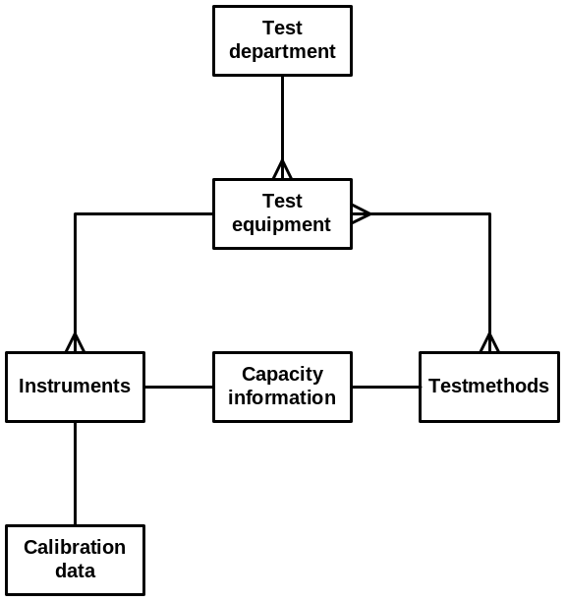

Entity | Description / definition
Test department | A department within the R&D organization performing specific type of tests and/or preparation (outdoor tyre testing, indoor tyre testing, chemical laboratory etc.)
Test equipment | Equipment to be used within a test department for testing
Test methods | One test equipment can perform several test methods and one test method may be performed on more than one test equipment.
Instruments | Equal devices for testing belonging to one code of test equipment
Calibration data | Per instrument calibration data can be stored (last calibration date etc.)
Capacity information | Per instrument capacity information can be specified related to the test methods to be carried out on this equipment (duration etc.)

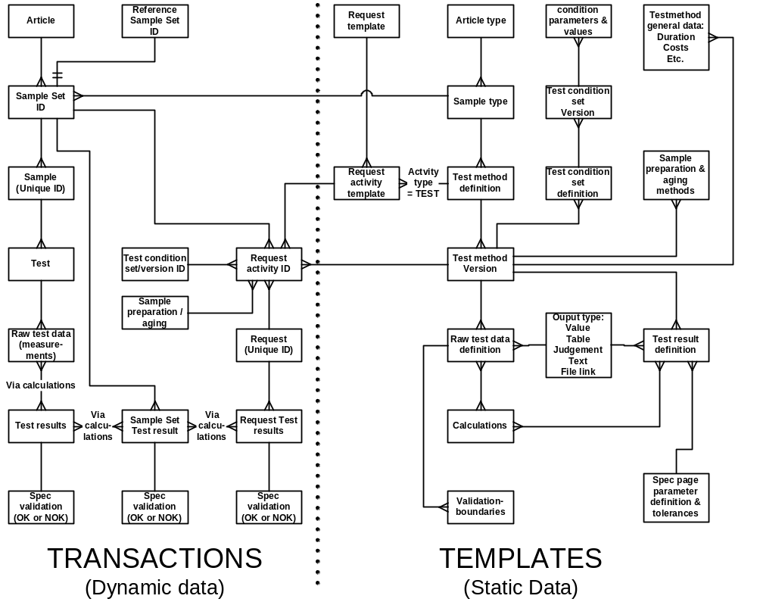

Entity | Description / definition
Article | A physical product where we can take samples of for testing.
Sample set ID | A request activity is related to one sample set ID. A Sample set is an amount of identical samples (4 equal tyres on a car, 3 samples taken out of a roll of ply etc.)
Reference Sample set ID | A sample set can be indicated as “Reference sample” with a certain reference ID. A test result of non reference samples can be compared to the test results of these reference samples. Also index calculations can be made for request results
Sample | The identical samples within a sample set do have their own unique identity.
Test | A test is done on a specific sample ID, using a certain test method and a specific set of test conditions. This is all specified in the request activity which can be based on some request template. It is always possible to do some additional tests (not scheduled via requests) on a specific sample. The tests and results are related to this sample ID.
Raw test data (tests) | Raw test data are output (tests) from the specified test method. Data can be of different types (Value, table, judgment, text, file link etc.)
Test results | Test results are the desired results of a test using a specific test method. The results are calculated from the raw tests via specified calculations.
Spec validation | A test result is compared to the product specification. Within these specifications, parameters and tolerances are specified. In the test templates a connection between the parameter and the test result is made. If a test result is within the tolerance limits the spec validation is OK.
Sample Set test results | For the whole sample set a test result can be calculated from the test results of the individual samples within this set. Example: Average test results + variances of all samples in one set.
Sample set spec validations | The outcome of the validation of the sample set test result has to be stored (OK or NOK)
Request activity ID | The instruction to test a sample set with a certain test method during certain test conditions is stored into the request activity
Test condition set ID | A certain set of test conditions can be selected during the creation of a request activity. Bases on the selected test method, one set of test conditions belonging to this method can be selected. Also the actual version ID of this set is copied into the request activity.
Sample preparation & aging | A certain preparation/aging method can be selected during the creation of a request activity. Bases on the selected test method, one preparation method belonging to this method can be selected.
Request | A request is a sequence of request activities
Request results | For the whole request a test result can be calculated from the test results of the individual test activities on sample sets using the test results of a sample set as input for these calculations. Via this method a calculation can be made for samples related to certain reference samples. (Index calculations regarding outdoor testing)
Request spec validation | The outcome of the validation of the request result has to be stored (OK or NOK)

TEMPLATES
Request template | Per request type a request template can be specified containing the general data of a request (order header info)
Request activity | Within a request template more activities may be specified. Activities can be of different types (see paragraph requests). The type “test” will be used in this paragraph.
Test method definition | A request activity in the request template (type “test”) can be connected to one test method.
Article type | Articles having the same manner of specifications are combined into one article type (Tyres, greentyres, threads, sidewalls etc).
Sample type | One article can deliver several kinds of samples. From article “tyre” we can take as a sample:  - The whole tyre  - A cross-section of the tyre  - A punched part of the tread  Etc.
Test method version | When a test method has to be changed a new version of the method will exist. This new version has to be approved and authorized in order to become the actual version (just one actual version can exist).
Sample preparation & aging | Per test method several sample preparation / aging methods are valid. In the template for a request activity of type “test” one preparation method may be selected (belonging to the combination sample type/ test method)
Test method general data | Per test method general data can be defined and default values can be assigned to this method. (Duration, capacity, costs etc)
Test condition set definition | To a specific version of the test method several sets of test conditions can be specified (high speed test with tyre pressure 1,2 or 3 combined with environmental temperature A,B,C.)
Test condition set version | When a set of test conditions has to be changed a new version of the set will exist. This new version has to be approved and authorized in order to become the actual version (just one actual version can exist).
Condition parameters & values | One set of test conditions may consist of several parameters and values (temperature = 30 degrees and tyre pressure = 2 bar)
Raw test data definition | Raw test data can be defined per test method. Data (tests) can be of different types (Value, table, judgement, text, file link etc.)
Calculations | Calculations of test results out of raw tests can be defined per test method.
Test result definition | Test results can be defined per test method. Test results can be of different types (Value, Boolean etc.) and Unit of Test
Validation boundaries | The raw test data can be checked against validation boundaries (example PH must be between 0 and 14). Per test these boundaries can be specified.
Spec page parameter definition & tolerance | This is the link between test result and the related specification parameter. Via this mechanism a test result can be validated against specification limits (tolerances).

Analysis and reporting

Introduction
Data is useless if it’s not used. We expect the new possibilities in the LIMS solution will enhance analysis and reporting. In the Vredestein way of working lot’s of data are obtained at different article type levels. To shorten the development cycle, correlations between outdoor and indoor tyre test results and between tyre test results and material test results are essential in realization of that goal.

General analysis and reporting facilities

Correlation

Current situation
Due to the fragmentation in the systems it is time consuming to create an overview of test results and the corresponding recipes. When relations between the material recipe and the material results or the tyre recipe and the tyre test are of interest the COMPOUND system and FITES system work quite well. However, for relations between tyre test results and material recipe or an overview of the processing test results the current situation is not very efficient.
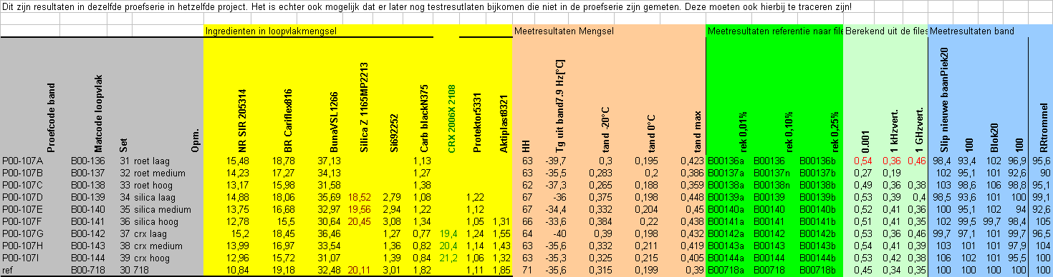

New situation
The relations visible in the above figure can be created from the LIMS. In this overview, the recipe information for the material in a specific part, the material test results and the tyre test results are in one table ready to be correlated. In the new situation standardized reports can be generated from the results.

Statistics on results in combination with the tolerances (specification)

Current situation
The COMPOUND system has statistic functionality and is able to plot (see figure below).
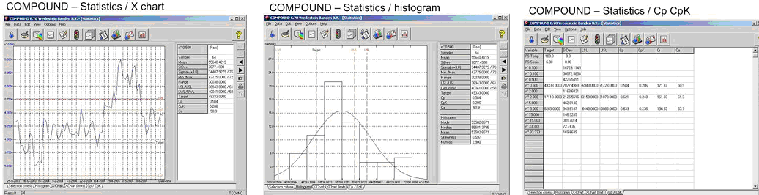

New situation
Similar functionality like the COMPOUND system is available in the LIMS for all articles. The functionalities should also include extra SPC possibilities.

Optimization of tyre/semi-finished product/compound portfolio

Current situation
From the SPECTRAC DB application an excel file PBW-OVERZICHT.XLS is created. In this file the recipe tree is transformed into one big table. Excel functionality like pivot tables are used to analyze our portfolio of articles.
A second overview is the generated from PG (AS400). From this database a treelike structure is build starting from the vulcanized tyre to the raw materials.

New situation
In the new situation both extracts can be exported from the LIMS to PWB-OVERZICHT.XLS.

A standard scientific report

Process
There are quite some projects that can run in a routine manner.

Current situation
It is time consuming to create a scientific report. For “simple” tests people don’t invest the effort in reporting the results of these tests carefully. One of the drawbacks is that if you find data in the database, you have to do the thinking again.

New situation
The effort for the specialists to add their thoughts to the tests is minimized. This information is stored together with the test results, so per request automatically a standard scientific report can be generated. A standard scientific report will consists of the sections:
- Summary (a long text field in the LIMS)
- Theory (short text field referring to document/literature)
- Experimental setup (these come from the LIMS as test method and recipes etc.)
- Results (these come from the LIMS as test results)
- Discussion (a long text field in the LIMS)
- Conclusion (a long text field in the LIMS)
- Reference (text field in the LIMS with (hyper-)links to other requests or documents
The text editor should be able to handle symbols, formula's and chemical structures.

Comparing graphs of x-y data

Current situation
In the COMPOUND system one can compare up till seven different datasets of x-y data in one plot.

New situation
This COMPOUND functionality is to be available for all x-y results. It has a more user friendly interface than the COMPOUND one.

Comparing graphs of z(x,y,t) data

Current situation
A number of test have as a result z(x,y,t) data. This information can be visualized with MatLab. However, selecting the data is a delicate task, as the sample and test information is not available with the test results. The filename and directory must provide enough information.

New situation
MatLab is started from the LIMS. The LIMS is interfacing the correct file name(s) belonging to the data one wants to analyze/compare in combination with the sample and test result information.

Compare functionality (diff function)

Current situation
In a lot of cases the difference in two recipes or specifications is of interest. In the current situation this a difficult tasks, because per article recipe up to 50 parameters have to be compared.

New situation
A “diff” function is available in the LIMS that highlighting the fields that are different.

Material Overview:

Current situation
The overview of raw materials and their status is manually updated in excel files.

New situation
The LIMS generates an overview (per article type) of all articles with a certain status (typically a production status). For raw materials this will yield the PROEFGRONDSTOFFEN.XLS and the ACTUEEL.XLS.

There should be an overview (per department) of all activities with a certain status (typically ready to process). Exporting this will give the info for the current planning lists of all manufacturing and testing departments
There should be an overview (per request) of all activities with a certain status (typically ready to process).

Activity Overview:

Current situation
In every department planning lists are generated by the laboratories.

New situation
Per department an overview of all activities with a certain status (typically “ready to process”) can be exported to excel.

Result overview

Current situation
In FITES and COMPOUND one can select a number of article codes and create a test result overview.

New situation
In the new situation the below is generated. If the test result is x-y data, one comparison plot is made with the x-y data of the selected articles, having a legend with the acticle code.
 |  | Article 1 | Article 2 | etc
 |  | Article1 code | Article2 code
Testcode 1 | Result entry 1.1 | value | value | value
Ageing code | Result entry 1.2 | value | value | value
Preperation code | Result entry 1.3 | value | value | value
Test setting code
Testcode 2 | Result entry 2.1 | value | value | value
Ageing code | Result entry 2.2 | value | value | value
Preperation code | Result entry 2.3 | value | value | value
Test setting code | Result entry 2.4 | value | value | value
 | Result entry 2.5 | value | value | value

Quality overview

Current situation
In the current situation quality overviews are generated for compounds and tyres (MKB/FITES) and for semi finished products and tyres. (quality audits) Creating these overviews happens manually and requires a lot of excel work.

New situation
It is possible to generate an overview of the quality level of the manufactured articles from the LIMS. The quality level can be expressed in the number of test out of spec. , with Cp/Cpk levels and other standard SPC tools. It is also possible to generate trend analysis of these levels. The quality overviews are defined (template) on articles (sub)types. It should be possible to determine filters on the results selection in order to obtain only the relevant data. For example only the results which have a pass status.

Approval documents

Current situation
The (Tri-)TA is a MS-word document in which the complete recipe, specifications and control plan of (an) article(s) is proposed to be approved and supported with test results. This information has to be copied pasted from other applications, or typed in for the first and only time.

New situation
All data related to defining the article is reported out of the LIMS. Off course all test results also need to be imported from the LIMS. When the articles are approved, the status of the article definition has to be changed. A mass update facility or doing the approval in the LIMS can be valid solutions

